The Test Pyramid with Python + pytest — RetailCo
The Test Pyramid is a strategy for deciding what kind of tests to write and how many of each.
For the RetailCo order-fulfilment service, a healthy test suite should have many fast unit tests, fewer integration tests, and a small number of slower end-to-end (E2E) tests.
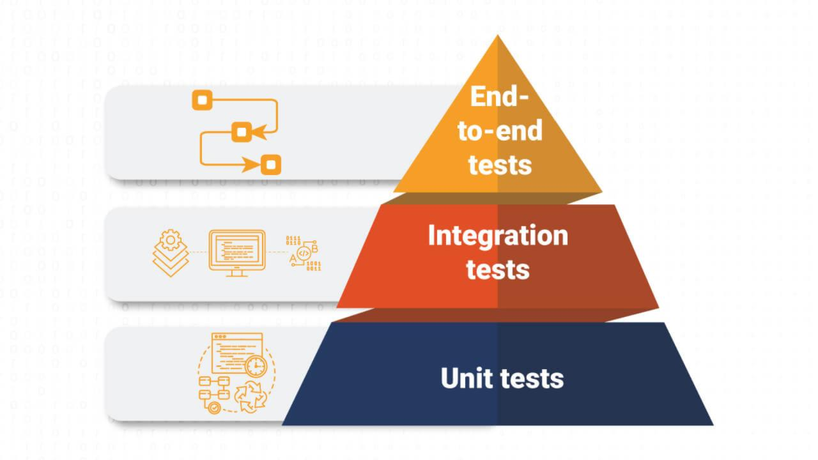
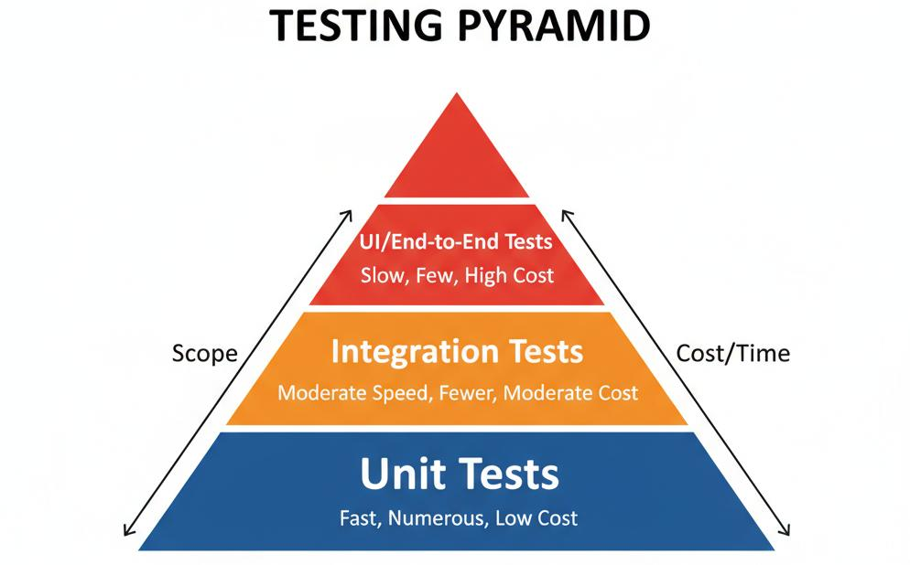
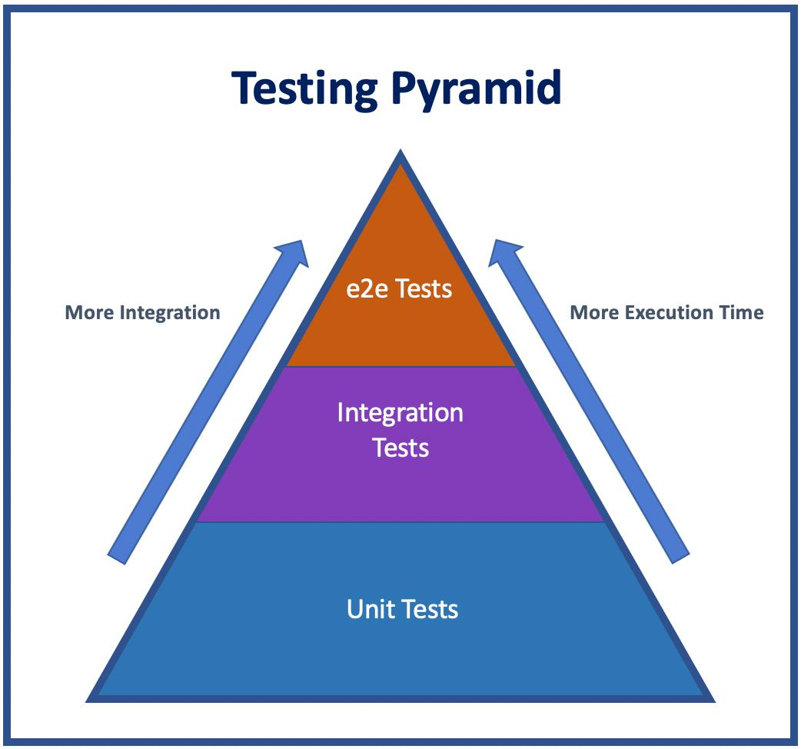
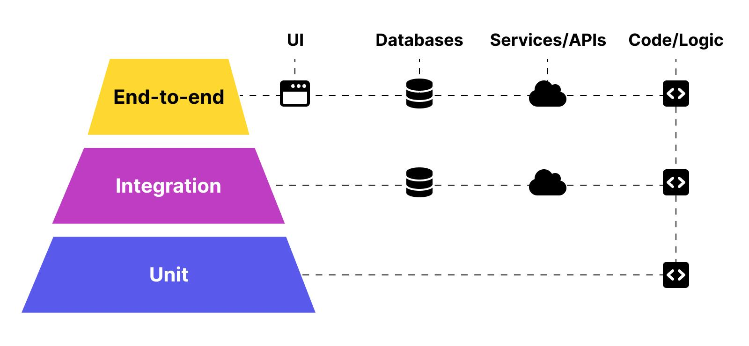
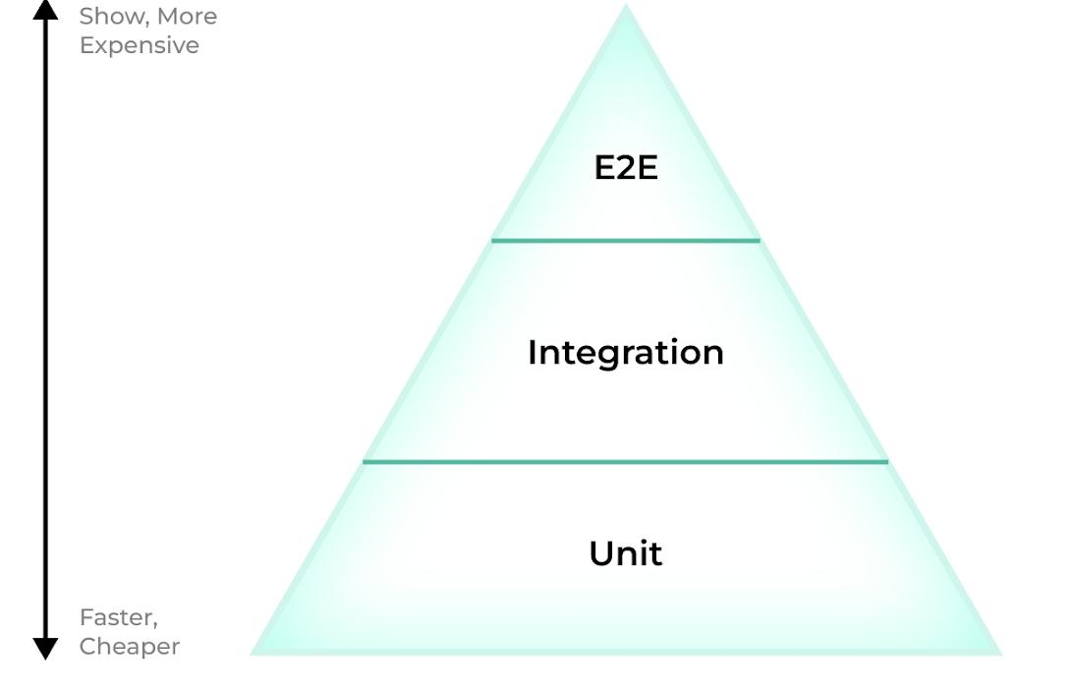

1. What is the Test Pyramid?
Think of your automated tests as a pyramid:
/\
/ \
/ E2E\
/------\
/ \
/Integration\
/------------\
/ \
/ UNIT \
/------------------\
From bottom to top:
Layer | Typical amount | Speed | Cost | Scope
Unit | 70% | Very fast | Low | One class/function
Integration | 20% | Medium | Medium | Multiple components
E2E | 10% | Slow | High | Complete application
The important idea is:
Most tests should be small and isolated. Fewer tests should exercise the entire system.

2. Unit Tests
Concept
A unit test tests one small piece of code in isolation.
For example, suppose RetailCo has an Order model.
class Order:
def __init__(self, order_id, customer_id, total_amount):
self.order_id = order_id
self.customer_id = customer_id
self.total_amount = total_amount

def is_high_value(self):
return self.total_amount >= 10000
We can test is_high_value() without:
- MySQL
- PostgreSQL
- FastAPI
- HTTP
- network
- Docker
- external services
That's a unit test.

3. Why Unit Tests Are Important
Suppose this method contains a bug:
def is_high_value(self):
return self.total_amount > 10000
A requirement says:
Orders >= ₹10,000 are high-value orders.
The test immediately identifies the boundary-condition bug.
Unit tests are:
- fast
- deterministic
- isolated
- easy to debug
- cheap to run
- suitable for CI/CD

4. RetailCo Order Model
Let's create a simple domain model.
app/models/order.py
from decimal import Decimal

class Order:
def __init__(
self,
order_id: int,
customer_id: int,
total_amount: Decimal,
status: str = "PENDING",
):
self.order_id = order_id
self.customer_id = customer_id
self.total_amount = total_amount
self.status = status

def is_high_value(self) -> bool:
return self.total_amount >= Decimal("10000")

def can_be_cancelled(self) -> bool:
return self.status in {"PENDING", "CONFIRMED"}
Our business rules are:
Order >= ₹10,000 → high-value

PENDING → can cancel
CONFIRMED → can cancel
SHIPPED → cannot cancel
DELIVERED → cannot cancel
CANCELLED → cannot cancel

5. Writing Unit Tests with pytest
Project structure:
retailco/
│
├── app/
│ ├── models/
│ │ └── order.py
│ │
│ └── services/
│
├── tests/
│ ├── unit/
│ │ └── test_order.py
│ │
│ ├── integration/
│ │
│ └── e2e/
│
└── requirements.txt
Install pytest:
pip install pytest
Run:
pytest

6. Unit Test #1 — High-Value Order
tests/unit/test_order.py
from decimal import Decimal

from app.models.order import Order

def test_order_is_high_value():
order = Order(
order_id=1001,
customer_id=501,
total_amount=Decimal("15000"),
)

assert order.is_high_value() is True
What is happening?
Arrange:
order = Order(...)
Act:
order.is_high_value()
Assert:
assert ... is True
This is the classic:
AAA Pattern

Arrange
↓
Act
↓
Assert

7. Unit Test #2 — Order Cancellation
def test_pending_order_can_be_cancelled():
order = Order(
order_id=1002,
customer_id=502,
total_amount=Decimal("2500"),
status="PENDING",
)

assert order.can_be_cancelled() is True
Again, this test doesn't need:
FastAPI
Database
SQLAlchemy
MySQL
HTTP
Docker
It tests only the Order object's behavior.

8. Add Boundary Tests
A good unit test suite shouldn't test only the obvious case.
Our rule is:
>= ₹10,000
So test the boundary.
def test_order_of_exactly_10000_is_high_value():
order = Order(
order_id=1003,
customer_id=503,
total_amount=Decimal("10000"),
)

assert order.is_high_value() is True
And below the boundary:
def test_order_below_10000_is_not_high_value():
order = Order(
order_id=1004,
customer_id=504,
total_amount=Decimal("9999"),
)

assert order.is_high_value() is False
This is much stronger than having only:
assert 15000 == high_value
because we have tested the business-rule boundary.

9. Test Cancellation Rules
def test_confirmed_order_can_be_cancelled():
order = Order(
order_id=1005,
customer_id=505,
total_amount=Decimal("5000"),
status="CONFIRMED",
)

assert order.can_be_cancelled() is True
And:
def test_shipped_order_cannot_be_cancelled():
order = Order(
order_id=1006,
customer_id=506,
total_amount=Decimal("5000"),
status="SHIPPED",
)

assert order.can_be_cancelled() is False
Now our unit suite tests several business rules.

10. Parametrization — Better Unit Testing
Instead of writing many almost-identical tests, pytest provides:
@pytest.mark.parametrize
Example:
import pytest
from decimal import Decimal

from app.models.order import Order

@pytest.mark.parametrize(
"amount, expected",
[
("500", False),
("9999", False),
("10000", True),
("15000", True),
],
)
def test_high_value_order(amount, expected):
order = Order(
order_id=1,
customer_id=1,
total_amount=Decimal(amount),
)

assert order.is_high_value() is expected
This gives us four test cases from one test function.

11. Integration Tests
Now move one level up.
An integration test checks whether multiple components work correctly together.
For RetailCo:
FastAPI
↓
Order Service
↓
SQLAlchemy
↓
Database
For example:
POST /v1/orders
↓
FastAPI route
↓
Pydantic validation
↓
OrderService
↓
SQLAlchemy
↓
MySQL
That's integration territory.

12. Example Integration Test
Suppose we have:
POST /v1/orders
Request:
{
"customer_id": 101,
"total_amount": 5000
}
An integration test could verify:
API request
↓
Service
↓
ORM
↓
Database
Example:
def test_create_order_persists_to_database(client, db_session):
response = client.post(
"/v1/orders",
json={
"customer_id": 101,
"total_amount": 5000
}
)

assert response.status_code == 201

order_id = response.json()["order_id"]

order = db_session.get(OrderModel, order_id)

assert order is not None
assert order.customer_id == 101
This isn't a pure unit test because it involves multiple components.

13. Unit vs Integration
Consider:
order.is_high_value()
Unit test:
Order
↓
is_high_value()
Integration test:
HTTP
↓
FastAPI
↓
Service
↓
SQLAlchemy
↓
Database
Therefore:
 | Unit | Integration
Database | No | Usually yes
HTTP | No | Often
External services | No | Sometimes
Speed | Very fast | Medium
Debugging | Easy | More difficult
Scope | Small | Multiple components

14. End-to-End Tests
E2E means End-to-End.
It tests the application from the user's perspective.
For RetailCo:
Client
↓
HTTP
↓
FastAPI
↓
Authentication
↓
Order Service
↓
SQLAlchemy
↓
Database
↓
Response
Potential E2E scenario:
Login
↓
Receive JWT
↓
POST /v1/orders
↓
GET /v1/orders/{id}
↓
PATCH order
↓
DELETE/cancel order
This tests the complete workflow.

15. Example E2E Test
def test_customer_can_create_and_retrieve_order(client):
login_response = client.post(
"/auth/login",
json={
"username": "customer@example.com",
"password": "secret"
}
)

assert login_response.status_code == 200

token = login_response.json()["access_token"]

headers = {
"Authorization": f"Bearer {token}"
}

create_response = client.post(
"/v1/orders",
headers=headers,
json={
"customer_id": 101,
"total_amount": 7500
}
)

assert create_response.status_code == 201

order_id = create_response.json()["order_id"]

get_response = client.get(
f"/v1/orders/{order_id}",
headers=headers
)

assert get_response.status_code == 200
assert get_response.json()["order_id"] == order_id
This is much broader than:
test_order_is_high_value()

16. Unit vs Integration vs E2E
A useful comparison:
Characteristic | Unit | Integration | E2E
Scope | Function/class | Components | Entire system
DB | ❌ | Usually ✅ | Usually ✅
HTTP | ❌ | Sometimes | ✅
External services | ❌ | Sometimes | Often
Speed | Very fast | Medium | Slow
Cost | Low | Medium | High
Debugging | Easy | Moderate | Difficult
Quantity | High | Medium | Low
Example | is_high_value() | Repository + DB | Login → Order → Retrieve

17. The 70/20/10 Guideline
A common guideline is:
70% Unit
20% Integration
10% E2E
Suppose RetailCo has:
100 automated tests
A reasonable target would be:
70 Unit tests
20 Integration tests
10 E2E tests
Visualized:
100 Tests
│
├── 70 Unit
│
├── 20 Integration
│
└── 10 E2E
The numbers aren't a law.
They are a design heuristic.

18. Applying 70/20/10 to an Existing Suite
Suppose your current RetailCo test suite contains:
Unit = 30
Integration = 40
E2E = 30

Total = 100
Current distribution:
Unit 30%
Integration 40%
E2E 30%
This is pyramid-inverted.
E2E
█████
███████
█████████

Integration
███████████
████████████

Unit
█████
You have too many expensive tests.

19. Refactoring the Test Distribution
Target:
Unit = 70
Integration = 20
E2E = 10
For 100 tests:
Current Target

Unit 30 → 70
Integration 40 → 20
E2E 30 → 10
What should we do?
Don't simply delete 20 E2E tests.
Instead ask:
"What behavior are these E2E tests testing that could be tested more cheaply at the unit or integration level?"
For example:
E2E test:
Create order → calculate total → save order → return response
Maybe split it into:
Unit:
Order total calculation

Unit:
Order validation

Integration:
Order persistence

E2E:
One complete create-order workflow

20. Why the Pyramid Matters
Imagine running:
70 unit tests
If each takes:
10 ms
Total:
700 ms
Very fast.
But imagine:
10 E2E tests
where each takes:
5 seconds
Total:
50 seconds
And that's only ten tests.
At scale, E2E tests become expensive.

21. Flaky Tests
A flaky test is a test that:
Sometimes passes
Sometimes fails
without a relevant code change.
For example:
pytest
Result:
98 passed, 2 failed
Run again:
pytest
Result:
100 passed
Run again:
pytest
Result:
99 passed, 1 failed
That's a major warning sign.

22. Common Flaky Test Patterns
Pattern 1 — Time Dependency
Bad:
def test_order_created_today():
assert order.created_at.date() == date.today()
This can fail around midnight.
Better:
def test_order_created_on_expected_date():
expected_date = date(2026, 8, 30)

assert order.created_at.date() == expected_date
Even better in application design: inject a clock/time provider.

23. Pattern 2 — sleep()
Bad:
def test_payment():
start_payment()

time.sleep(2)

assert payment_completed()
This is fragile.
The system might need:
2.1 seconds
instead of:
2 seconds
Now the test fails.
Better:
wait_until(
lambda: payment_completed(),
timeout=10
)
Or, ideally, test asynchronous behavior deterministically rather than relying on arbitrary sleep.

24. Pattern 3 — Shared Mutable State
Bad:
orders = []

def test_create_order():
orders.append("ORDER-1")

assert len(orders) == 1

def test_second_order():
orders.append("ORDER-2")

assert len(orders) == 1
The second test depends on the first test.
Test isolation is broken.
Better:
def test_create_order():
orders = []

orders.append("ORDER-1")

assert len(orders) == 1
Each test owns its state.

25. Pattern 4 — Test Order Dependency
Bad:
def test_create_customer():
global customer_id

customer_id = create_customer()

def test_create_order():
create_order(customer_id)
This assumes:
test_create_customer
runs before:
test_create_order
pytest does not guarantee that your business logic should depend on test ordering.
Each test should establish its own prerequisites.

26. Pattern 5 — Random Data
Bad:
def test_order():
amount = random.randint(1, 10000)

assert amount > 0
A random test may eventually expose unexpected behavior.
Better:
def test_order():
amount = 5000

assert amount > 0
If randomness is genuinely required, use a fixed seed and capture/report the seed when failures occur.

27. Pattern 6 — Real External Services
Bad:
def test_send_notification():
response = requests.post(
"https://notification-service.example.com/send"
)

assert response.status_code == 200
This test can fail because:
Internet
Service outage
DNS
Authentication
Network latency
Rate limiting
The application code may be perfectly correct.
For unit tests, mock the dependency:
def test_send_notification(mock_notifier):
mock_notifier.send.return_value = True

result = notify_customer(mock_notifier)

assert result is True
mock_notifier.send.assert_called_once()
Then have a smaller number of integration/E2E tests verify the real integration.

28. Diagnosing Flaky Tests
When a test appears flaky, run it repeatedly.
pytest tests/unit/test_order.py -x
For repeated execution, a useful plugin is pytest-repeat:
pip install pytest-repeat
Then:
pytest tests/unit/test_order.py --count=50
If you see:
49 passed, 1 failed
you have evidence of nondeterminism.
You can also use:
pytest --collect-only
to inspect what pytest is collecting, and:
pytest -vv
for more detailed execution information.

29. A Practical Flaky-Test Investigation
Suppose:
def test_order_status():
order = get_order(1001)

assert order.status == "CONFIRMED"
Sometimes:
PASSED
Sometimes:
FAILED
Expected: CONFIRMED
Actual: SHIPPED
Ask:
Question 1
Is another test changing order 1001?
Question 2
Is the database shared between tests?
Question 3
Is another process modifying the record?
Question 4
Does test execution order matter?
Question 5
Is the test relying on current time?
Question 6
Is an external service involved?
Question 7
Is asynchronous processing involved?
This turns "pytest randomly fails" into a systematic debugging exercise.

30. pytest Fixtures for Isolation
Fixtures are extremely useful for creating clean test data.
import pytest

from app.models.order import Order

@pytest.fixture
def pending_order():
return Order(
order_id=1001,
customer_id=501,
total_amount=5000,
status="PENDING",
)
Test:
def test_pending_order_can_be_cancelled(pending_order):
assert pending_order.can_be_cancelled() is True
Another test:
def test_pending_order_is_not_high_value(pending_order):
assert pending_order.is_high_value() is False
Each test receives a controlled object.

31. Complete RetailCo Unit Test File
A good starting point:
import pytest
from decimal import Decimal

from app.models.order import Order

@pytest.mark.parametrize(
"amount, expected",
[
("500", False),
("9999", False),
("10000", True),
("15000", True),
],
)
def test_high_value_order(amount, expected):
order = Order(
order_id=1001,
customer_id=501,
total_amount=Decimal(amount),
)

assert order.is_high_value() is expected

def test_pending_order_can_be_cancelled():
order = Order(
order_id=1002,
customer_id=502,
total_amount=Decimal("5000"),
status="PENDING",
)

assert order.can_be_cancelled() is True

def test_confirmed_order_can_be_cancelled():
order = Order(
order_id=1003,
customer_id=503,
total_amount=Decimal("5000"),
status="CONFIRMED",
)

assert order.can_be_cancelled() is True

def test_shipped_order_cannot_be_cancelled():
order = Order(
order_id=1004,
customer_id=504,
total_amount=Decimal("5000"),
status="SHIPPED",
)

assert order.can_be_cancelled() is False
Run:
pytest -v
Expected:
============================= test session starts =============================

tests/unit/test_order.py::test_high_value_order[500-False] PASSED
tests/unit/test_order.py::test_high_value_order[9999-False] PASSED
tests/unit/test_order.py::test_high_value_order[10000-True] PASSED
tests/unit/test_order.py::test_high_value_order[15000-True] PASSED
tests/unit/test_order.py::test_pending_order_can_be_cancelled PASSED
tests/unit/test_order.py::test_confirmed_order_can_be_cancelled PASSED
tests/unit/test_order.py::test_shipped_order_cannot_be_cancelled PASSED

============================== 7 passed ==============================

32. Recommended RetailCo Test Structure
For your FastAPI + SQLAlchemy RetailCo capstone, I'd structure tests like this:
tests/
│
├── unit/
│ ├── test_order.py
│ ├── test_order_service.py
│ ├── test_price_calculator.py
│ ├── test_validation.py
│ └── test_auth.py
│
├── integration/
│ ├── test_order_repository.py
│ ├── test_order_api.py
│ ├── test_database.py
│ └── test_auth_database.py
│
└── e2e/
├── test_customer_order_flow.py
└── test_order_fulfilment_flow.py
The conceptual distribution:
E2E
▲
/ \
/10%\
/-----\
/ \
/ 20% \
/Integration\
/-------------\
/ \
/ 70% \
/ UNIT \
/---------------------\

33. What Should Be Tested at Each Level?
Unit
Test business rules:
Order.is_high_value()
Order.can_be_cancelled()
Order.calculate_total()
Order.validate_status()
Integration
Test component interaction:
FastAPI + Service
Service + Repository
Repository + Database
SQLAlchemy + MySQL
E2E
Test important business journeys:
Login
↓
Create Order
↓
Retrieve Order
↓
Update Order
↓
Fulfil Order

34. The Key Principle
Don't think:
"Every feature needs a unit test, integration test and E2E test."
Think:
Test each behavior at the lowest level that gives you sufficient confidence.
For example:
Order amount calculation
↓
UNIT
No reason to start a database just to test arithmetic.
But:
SQLAlchemy correctly saves an Order
↓
INTEGRATION
A database is relevant here.
And:
Customer logs in and successfully creates an order
↓
E2E
The complete system matters here.

35. Exercise — Apply It to RetailCo
Suppose you inherit this suite:
Test | Current type
Calculate order total | E2E
Validate order amount | E2E
Check high-value order | Integration
Check cancellation rule | E2E
Repository saves order | Integration
Repository finds order | Integration
Login | E2E
Create order API | E2E
Update order API | E2E
Delete order API | E2E
Current problem:
Too many E2E tests
Too few unit tests
Refactor conceptually:
Calculate order total
↓
UNIT

Validate order amount
↓
UNIT

Check high-value order
↓
UNIT

Check cancellation rule
↓
UNIT

Repository saves order
↓
INTEGRATION

Repository finds order
↓
INTEGRATION

Login
↓
E2E

Create order API
↓
INTEGRATION

Update order API
↓
INTEGRATION

Complete customer order journey
↓
E2E
This makes the suite faster, cheaper and easier to diagnose.

36. Final Takeaway
For your RetailCo FastAPI project, remember:
E2E
10% | Slow
|
Integration
20% | Medium
|
UNIT
70% | Fast
Unit
"Does this piece of code work?"
order.is_high_value()
Integration
"Do these components work together?"
FastAPI → Service → SQLAlchemy → Database
E2E
"Does the complete user/business journey work?"
Login → Create Order → Retrieve → Fulfil
Flaky test
"Does it sometimes pass and sometimes fail without a relevant code change?"
Look for:
❌ sleep()
❌ current time
❌ random data
❌ shared mutable state
❌ test ordering
❌ real external services
❌ shared database state
❌ race conditions
70/20/10
For every 100 tests, aim roughly for:
70 Unit
20 Integration
10 E2E
—not as a rigid rule, but as a useful starting point for keeping the RetailCo test suite fast, reliable and maintainable.

